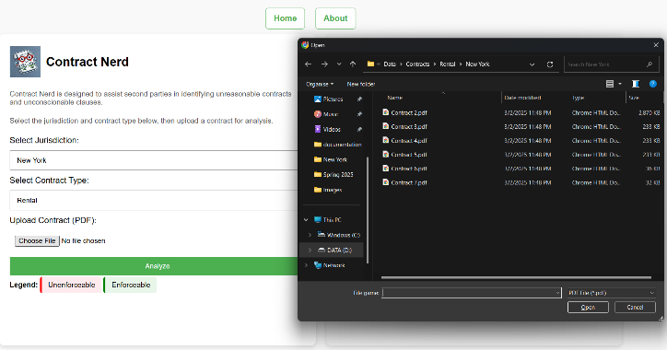

2

7

6

5

4

3

1

Database

**Database**Contains gold standard contracts, state-level regulation documents, examples of risky clauses

Gold standard contract

Regulations

Risky Clauses

Linguistic Definitions

LLaMA prompt: Listing 2

LLaMA prompt: Listing 3

LLaMA prompt: Listing 3

LLaMA prompt: Listing 1

**Front-end/User Interface: HTML, CSS, Javascript**Contract uploaded to be analyzed, Analysis returned

User Interface

**Back-end: Python**Uploaded contract compared against stored documents/text using LLaMA prompts

Back-end